**Coffee Shop Sales Report**

**-Problem Statement:  
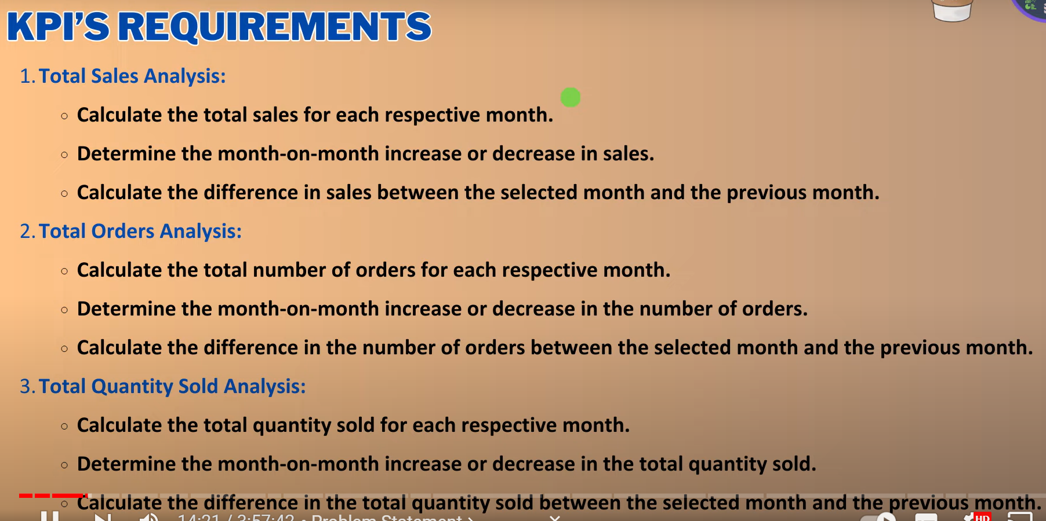  
  
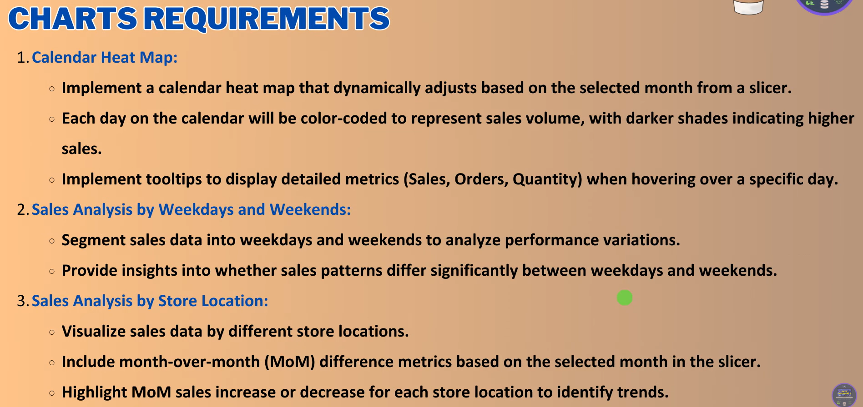  
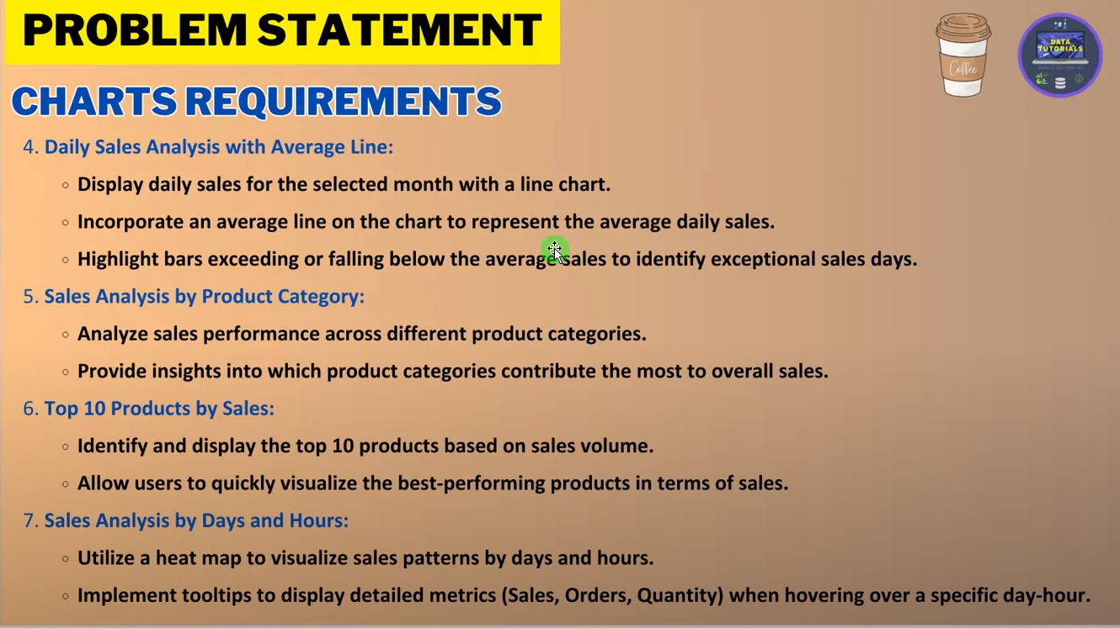  
  
Excel or csv file is moved into powerBI desktop  
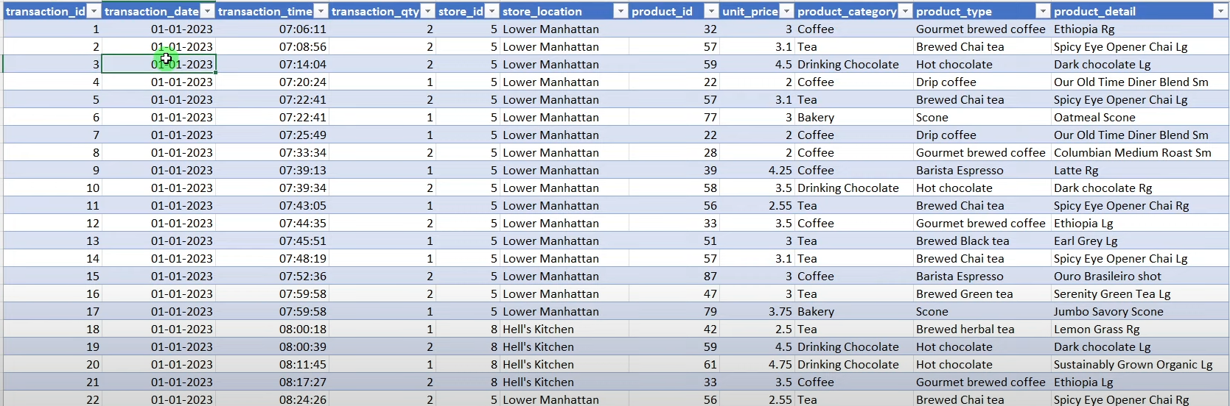**-transaction id is unique  
-we have 6 months dates data  
-it has 149116 rows  
-At wat tym order has been ordered   
-we have store Id, location, product id  
-Below is report we need to prepare  
**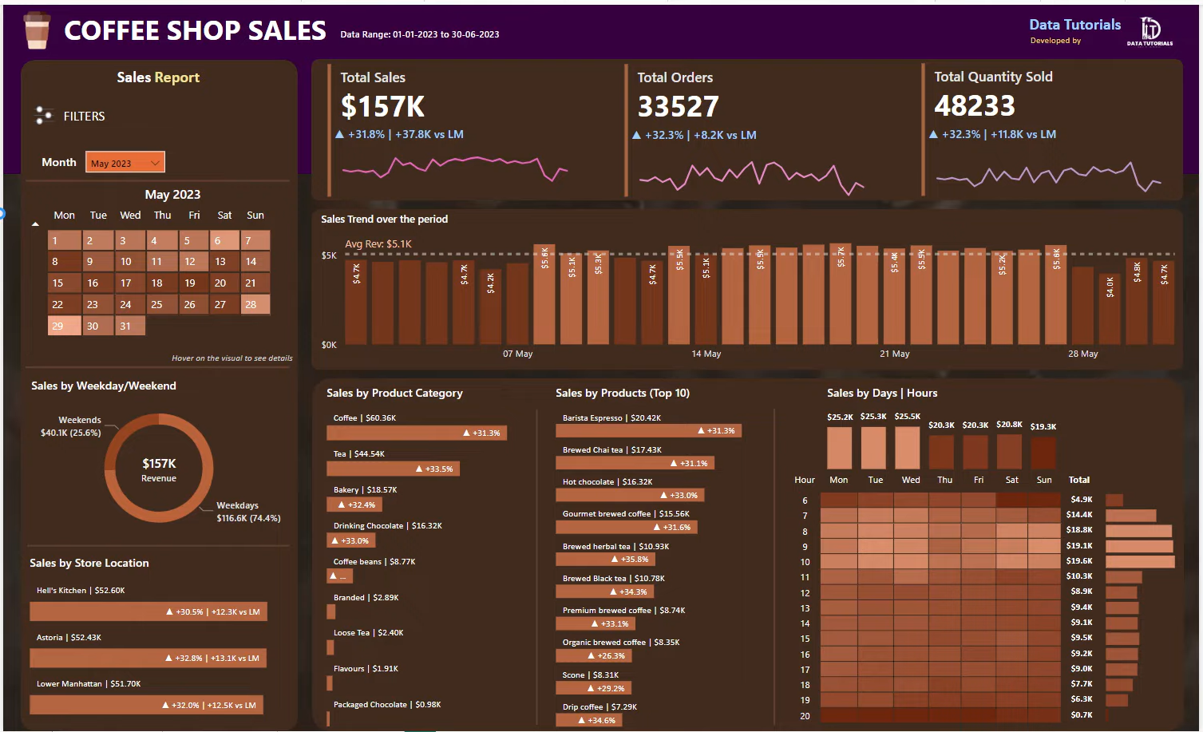  
In desktop we need to check as below:**-In **Transaction time** we havedates so we are checking the hourly based data , so convert it into Hours  
-Now we have to create a Calendar table,  
-70% we need to deal with Date functions, so we recommend calendar table compulsory  
- **-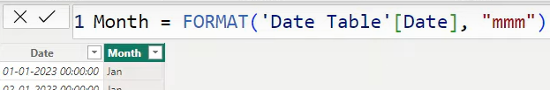  
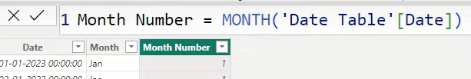**Always recommended to create 1 to *Many relationship  
-Now go to report view or canvas  
-browse for background colour & check the transparency 100 to 0  
-Once give Titles, background colours & then start the KPI’s requirement  
**-Create Sales(calculated Column)- Sales & Total Sales(measure)**  
-Now create a card & give total sales & also a slicer for month wise sales  
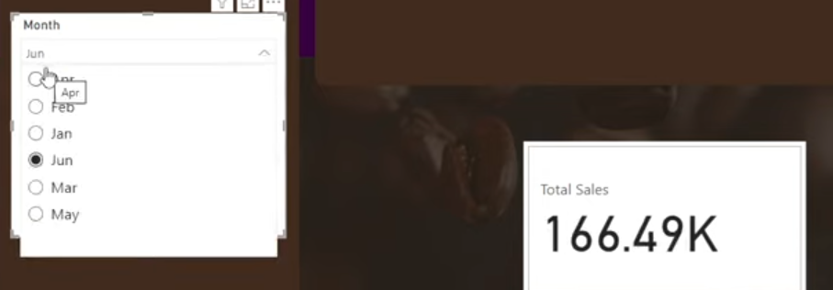  
-we should check the backgrounds , $ , Format…etc,   
- Now we need the date hierarchy for the graphical representation instead of (.), use as below  
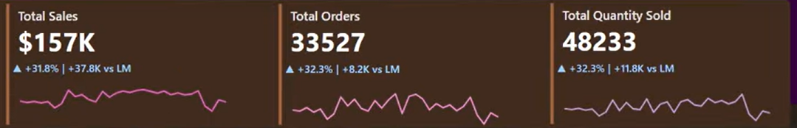  
-as above we need to have custom indicators   
-Now find Month on month Difference, inc & Dec Compare to Previous month  
-Calculate Current Month & Previous month sales(Measure)  
-Calculate MoM Sales & % Custom dynamic measure , if Jan get total sales & below it won’t have previous sales data , so condition is “no previous month data”.  
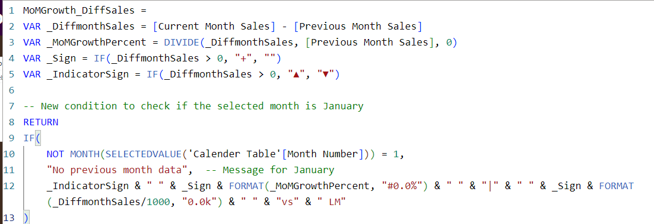  
-Once we calculate the above measure , we need to add this measure to fx in Format  
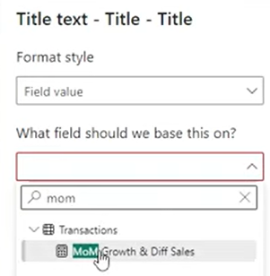  
-For this we need to create Day, Day name,   
Week Num – in the table week Num starts from Sunday , so Sunday will be “1”…….Monday is “2”…. So…on  
  
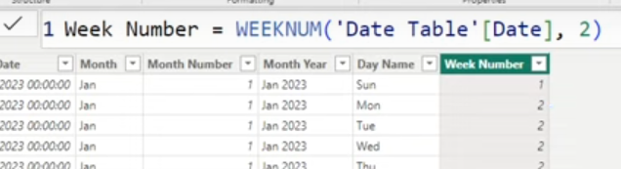  
-Now we have to bult the calendar customised chart as below:  
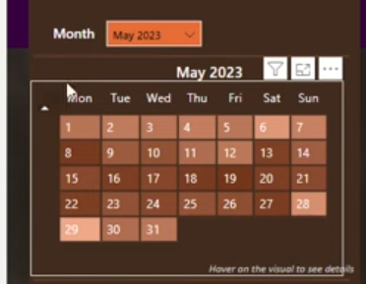  
  
-For the below chart we need to find the avg line, with respect to selected month, Dax, conditional formatting  
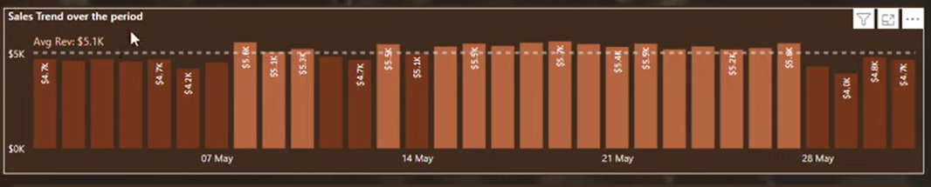  
  
  
  
  
- it will be as below Chart  
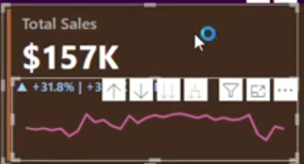  
-In above Card it has separate 2 charts , so in order to create other 2 cards we need to group those charts so it won’t get clumsy, so whenever we move the card it will move as one(**Click on chart & press Control then click total sales chart & then right click option group**)  
-For any formatting we need to click the grouped chart 2 times   
-Now Create a measure “Total Orders “ Distinct Count (transaction ID)  
- Copy above chart & Add Total Orders instead of Total Sales & Change the Display Units from Auto to none  
-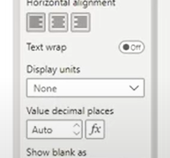  
- Similarly Create For Total Orders, Total Qty , Mom ,Diff For both as below  
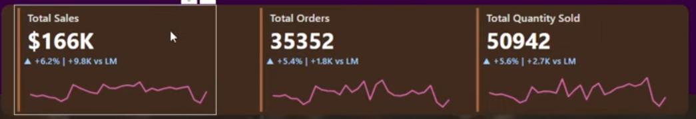  
- Now align it as below  
by pressing control select we get as below , go to format (align) & distribute Horizontally  
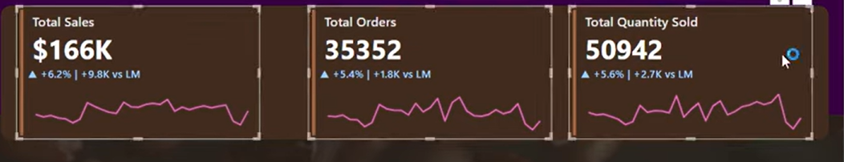  
-In selected Month when we click on “Jan” we are getting infinity as below, we need to overcome it  
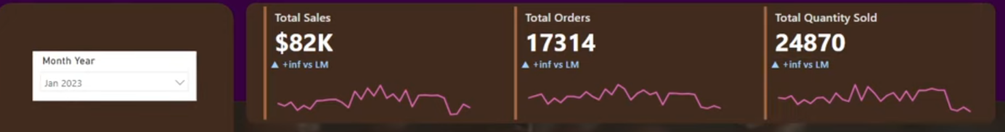  
- For the below calendar we need to do some formats like  
-take Matrix Chart  
-Grid: Hor/vertical Colour changes, width-2  
-Values-  
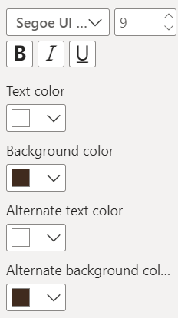  
-Column Headers  
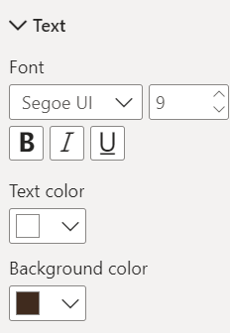  
  
  
-Row Header  
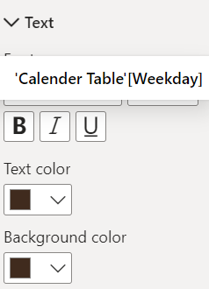  
-Cell Elements 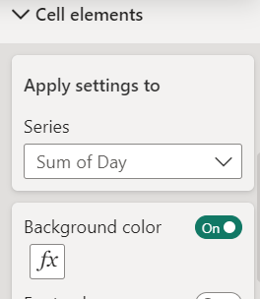click on fx  
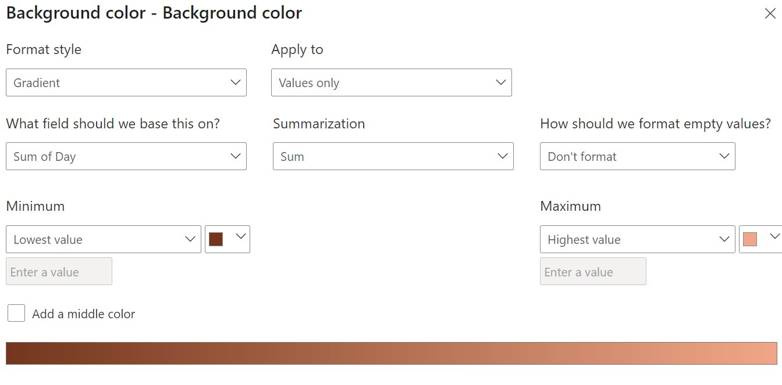  
-Change the row name Week Num to “Space” , & we get as below  
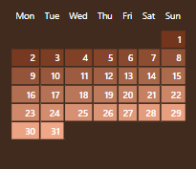  
-In order to get the header for the calendar  
- we need to take one card & do some formats  
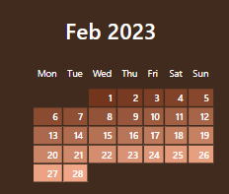  
-Create one measure “Hover on this visual to see the details” & add it to Card & do some formats as below  
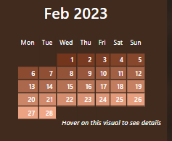  
-Now create a tooltip in page2 Tool tip -calendar chart  
-now go to canvas setting put as tooltip  
now add below changes , formats, use cards(horizontals, labels, colours…etc)  
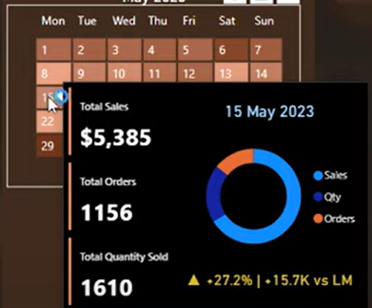  
  
**Now create a Bar chart For Store Location by sales**:  
-In this we need to firstly create a placeholder, becz previously Helans kitchen is near the bar chart, where we need to make it top of bar chart , so we use measure Placeholder =0  
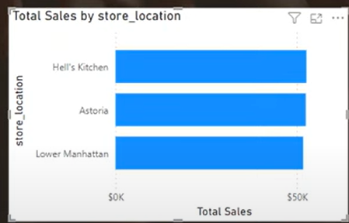= 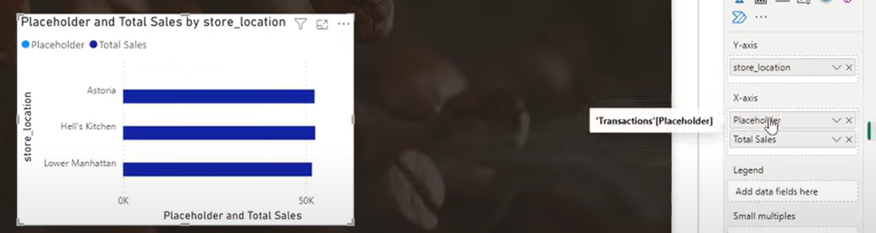  
Fields:  
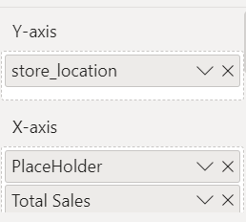  
-So In the format , go to Data labels wen we have place holder & Sales,   
when label is Placeholder we need to give measure as below & change in Values:  
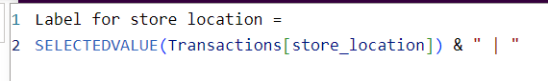  
  
  
When its Total sales in labels , we need to change Values as below  
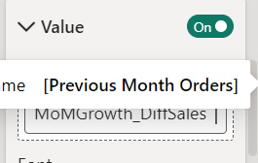  
  
Then we transformed into  
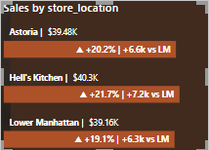  
  
**Now create as below, we used column chart instead of line chart:**  
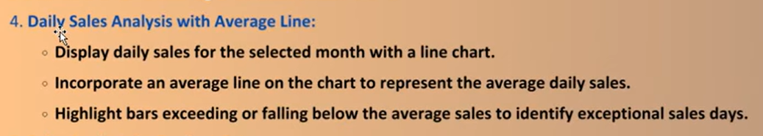 **-Use Column Chart , remove grid lines,**Add daily avg sales in measure**:  
  
-now add the above measure as the constant line in search  
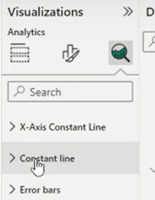 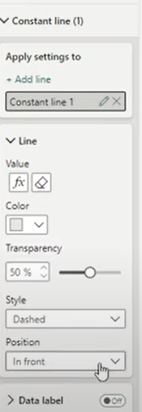**Now create a Bar highlight whether its Above avg or below avg   
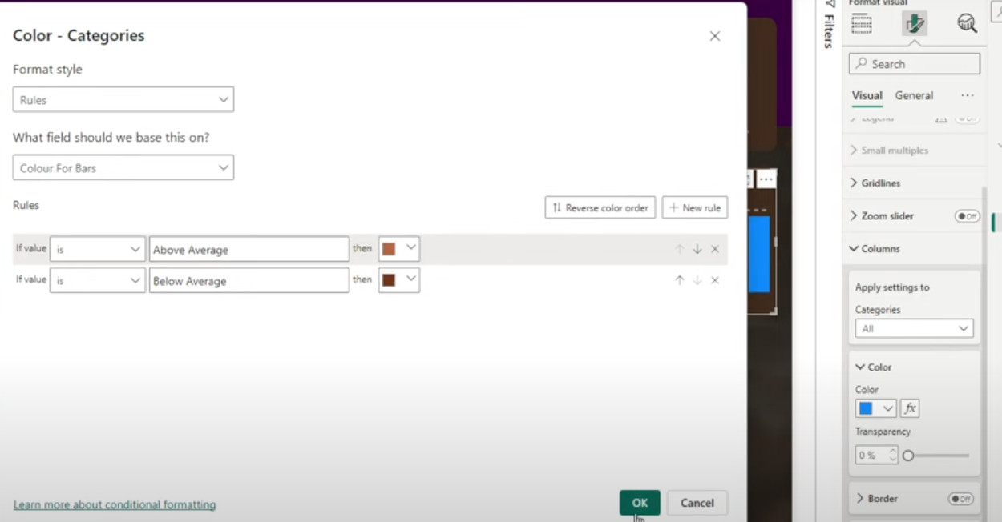Final output for Column Chart as below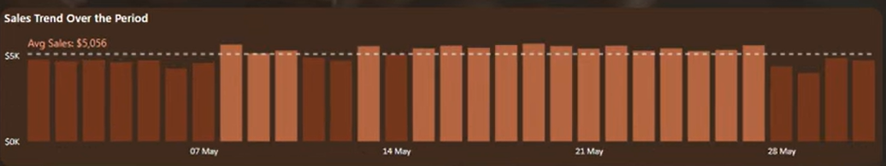

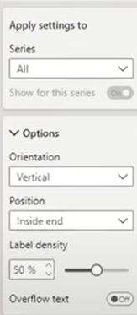  
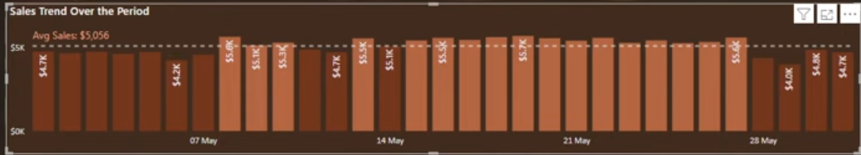  
  
Similarly Follow the steps for as store location  
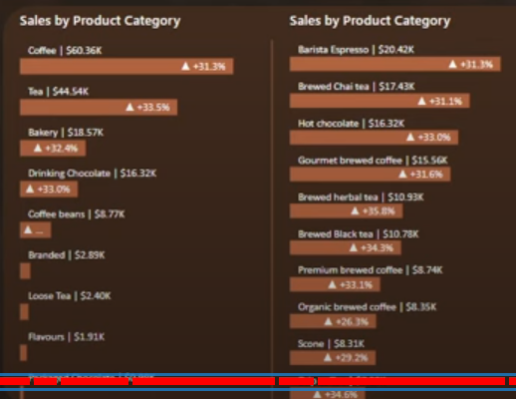  
  
Heat Map  
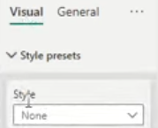  
  
Grid For both hor/Vertical Same colours  
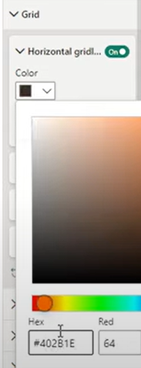  
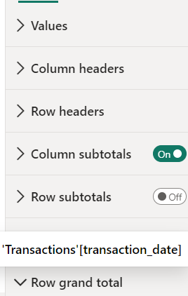  
Specific Column:  
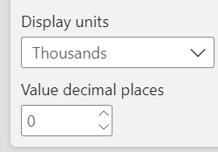  
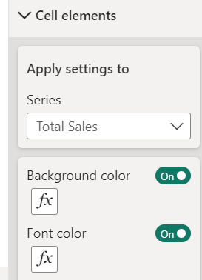  
Background Colour  
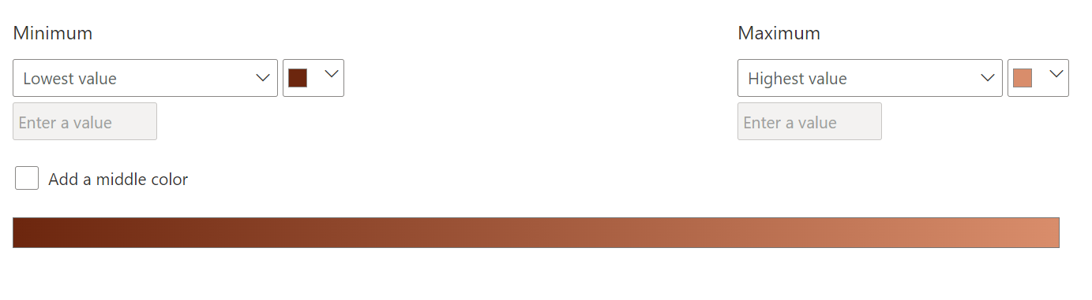  
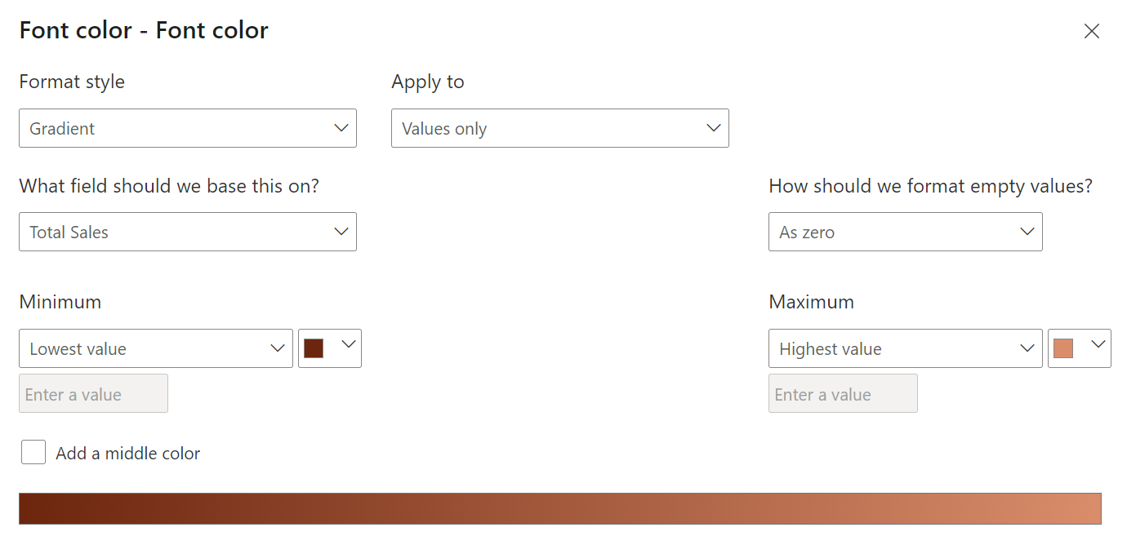  
-Once done we need to hover the sales chart for Hour & Day  
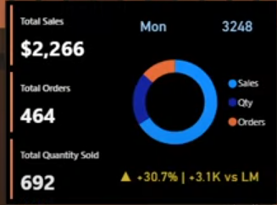  
duplicate the same & change as above  
  
Concatenate as below :  
